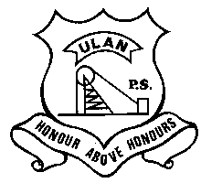 | ULAN PUBLIC SCHOOL  A member of the Cudgegong Learning Community – promoting public education  Main Street, ULAN NSW 2850  Ph: 0263 734625 Fax: 0263 734807 ABN: 7 139 345 454 | CUDGEGONG LEARNING COMMUNITY

NEWSLETTER 19th February 2020
TERM 1 Week 4
SWIMMING CARNIVAL
Yesterday 8 amazing UPS students competed at the Mudgee Small Schools Swimming Carnival in a variety of age groups, swim strokes and distances.
Every single one of them received a placing in one or more races and they were all hugely encouraging of each other as well as their competitors from the other small schools.
Each student has written a short text about how they performed and enjoyed themselves yesterday.
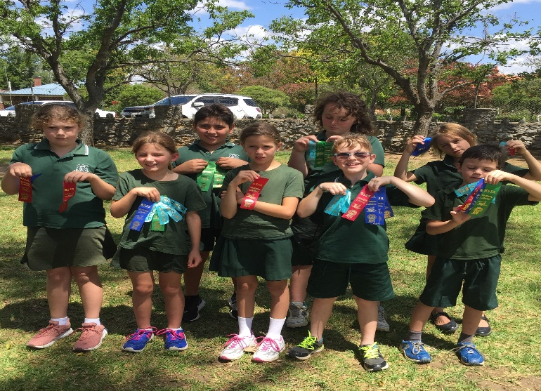
CAKE DAY
Wednesday 26th is Cake Day, the students & staff can purchase cakes/slices at recess for 50c, which have been donated by the families rostered to donate. This is a P&C fundraiser. The families rostered to donate cake/slice this Cake Day are: Bierton, Birchall, Hartley & Hodge
LUNCH ORDERS
Wednesdays is lunch order day please find attached a lunch order form. Please put your orders in on Friday morning. This is a P&C fundraiser.
MELTIES
Don’t forget if your child would like their sandwich toasted on Friday’s, to bring it to the staffroom so it can be toasted and ready for lunchtime.
UPCOMING EVENTS
Thursday 27th March -Clean Up Australia at School.
Sunday 1st – Monday 2nd March - Year 6 Young Leaders Excursion to Sydney
Tuesday 3rd March – Life Education Van Visit to UPS (with Goolma PS & Cassilis PS)
Thursday 5th March – Friday 6th March – Year 5/6 Eco-Schools Leadership excursion to Red Hill
STUDENTS OF THE WEEK
Ulan Junior – Heath Robinson for always being extremely helpful.
Ulan Senior – Olivia Hartley for a wonderfully positive attitude to life and learning.

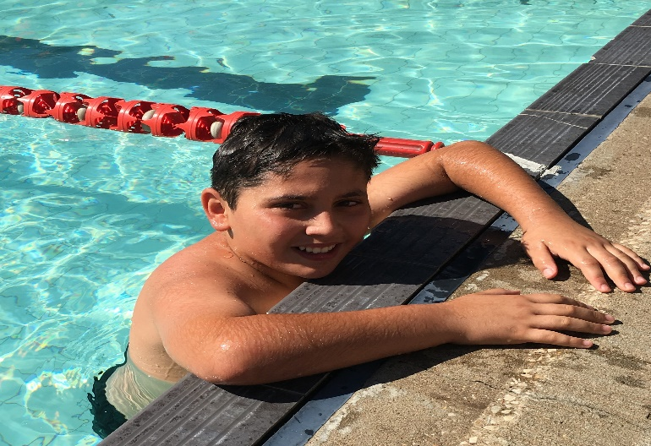

Yesterday I swam in the 100m freestyle, 50m freestyle, breaststroke, backstroke, and butterfly. I also made it on to the UPS relay team
My best performance was freestyle because it is the one l am the best and the quickest at.
I hung out with my friends Saxon, Oscar Jayden and Ricky. They were from Hargraves, Ilford, and Lue.
My most fun thing was hanging out with all my friends and competing in the events.
I think I will make it to the Zone carnival for freestyle and breaststroke because I was the best at those two. They were my quickest laps of the pool.
Tyler

Tesha swam in the 50m freestyle, breastroke and backstroke as well as the 16m butterfly. She also made the UPS relay team.
Her best result was third in the 50m freestyle.
She hung out with Holly, Allegra and Chelsea from Hargraves. These girls are all her friends from Broken Bay camp last year.
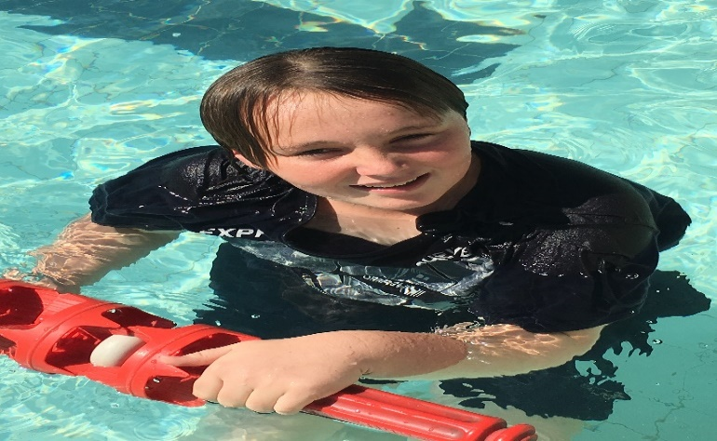
Yesterday at the swimming carnival was the best. I swam in the 33m race for freestyle and came 2nd, and I did all the 16 metre races for freestyle (1st), butterfly (1st), breaststroke (1st) and backstroke (1st).
I think I'm best at 16m breaststroke, because I'm fast and I waited in the water for the whistle and I practiced my breathing while I waited as well.
I didn't know any other people there because I did not go to any of those small schools that were there at the swimming carnival.
Playing tips with all the little kids was the best, it was just so much fun and I loved playing around with them while we waited for my races and I played games with my friends at Ulan and it was so much fun.
I don't think I could get into the zone races because I cannot swim 100m, I'm not a great swimmer. The only big race I know I can do so far is 33m.
Cory
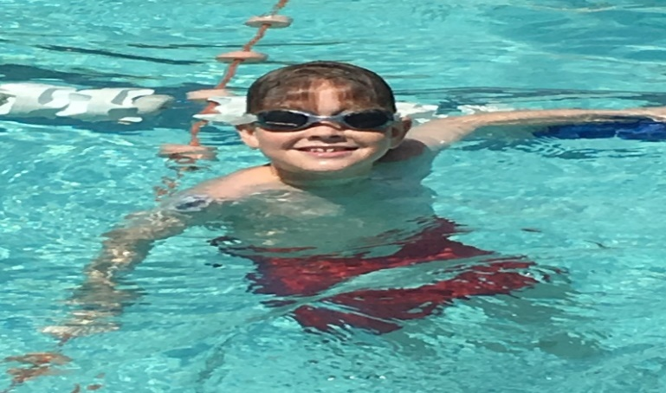
Yesterday I swam in 33m freestyle, breastroke, backstroke and butterfly and I also made it into the 50m relay team which was scary.
At the swimming carnival I think the best race I did was backstroke because I came second and didn’t know at all.
The friends I saw from other small schools were Holly, Allegra, Chelsea, Brook, Siena and Kalista. I saw them all at Broken Bay camp.
The funniest thing about the day was when I got out of the pool and ran to Tesha and hugged her because she was dry and had not got in the pool.
I do believe I might have made it to Zone because I came second in backstroke but I didn’t know until I got my ribbon and I was so happy.
Olivia
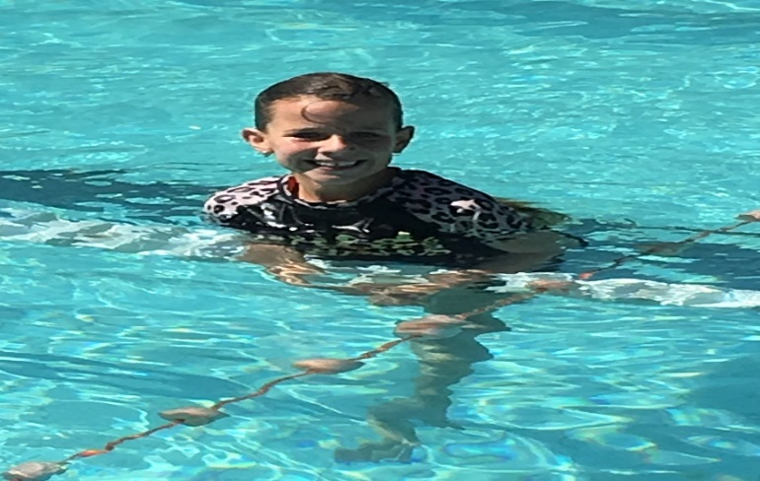
Yesterday I swam in the 50m freestyle , backstroke and breastroke as well as the 16m butterfly. I also made the UPS relay team.
The funniest thing was swimming in the relay with Tyler, Olivia, Tesha and me. It was the funniest thing I did.
Lucy
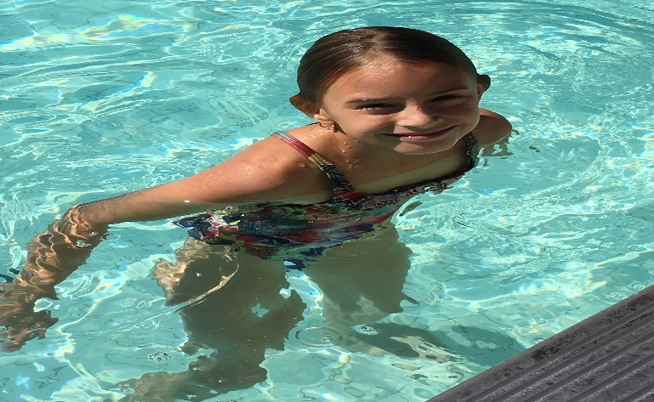
Yesterday I swam 16m backstroke, breaststroke and freestyle but I wanted to swim the whole pool but I would run out of breath.
My best race was the freestyle I just wanted to come first, second or third
But if I came forth fifth or sixth because I would lose and not get a ribbon.
I saw Holly, Siena and Allegra. They were my best friends from Rylstone Public School. Siena taught me how to do the splits cartwheels and handstands.
The most fun thing was swimming because I just always wanted to get in the water because it was a very hot day but I had to wait my turn
I don't think I will make it to the Zone carnival because I didn't swim 100m with the big kids, but I was a junior. Maybe next year!
Skye
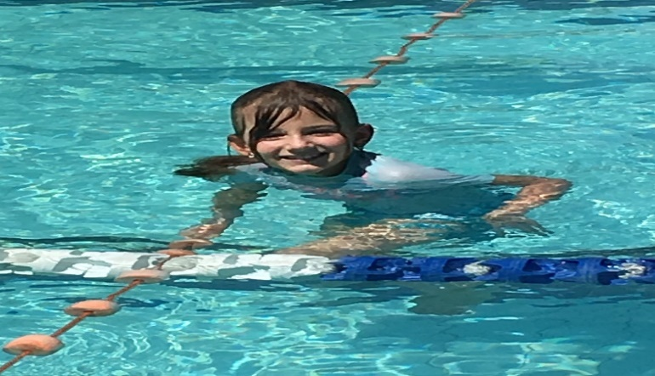
Yesterday I swam in the 16m freestyle, backstroke and breaststroke.
My best race was backstroke in 16m. I came 2nd in the race.
I saw Brook from Lue PS and played with her.
I had an awesome day and swam really well.
I don’t think I will make it to Zone because I only swum 16m.
Ashlee
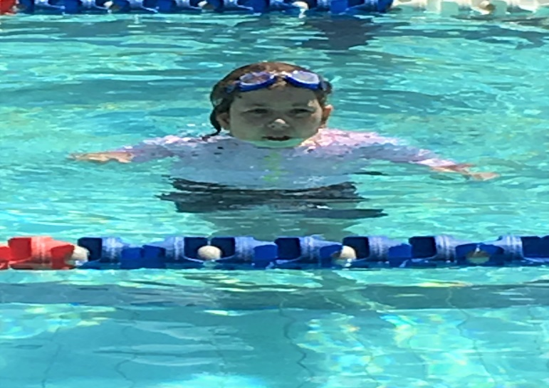
I swam in Backstroke - 16m, Breaststroke - 16m, Butterfly - 16m and Freestyle - 16m
My best races were backstroke and breaststroke because I came 1st in both.
The friends from other small schools I saw were Holly from Lue School.
The most fun thing about the day was just swimming because it was so nice and sunny.
No I won’t qualify for the Zone carnival because I only went in the 16m races not the 50m races. Next year I am going to try the 50m races.
Aaron
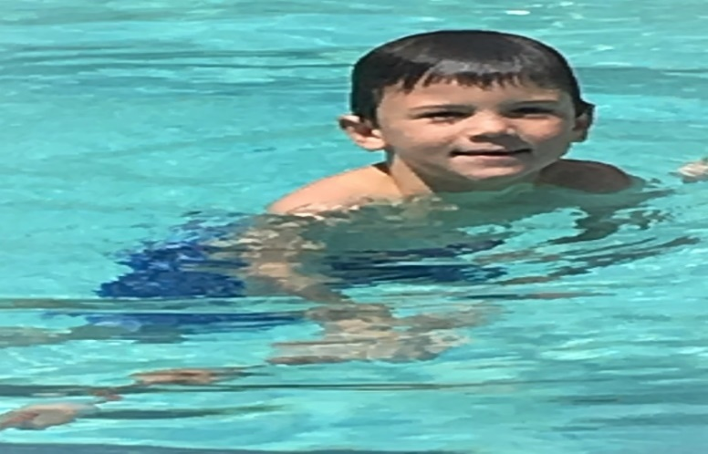

My day with Jack
Yesterday I came to school and I went down to the playground with Jack for 5 mins before the bell. When the bell went jack and I went inside. Miss Chamberlain had to do a kindergarten test with Jack. While I cut up some numbers and played on my chromebook. Then Jack and I got to go to recess 50mins early. After Jack and I ate we went to the playground and played chase with each other. After I went up to the tables and sat down. Then about 10 mins later Jack came up and asked me to play at the playground with him and he also said sorry for scaring me but then the bell went.
After recess me and Mrs Baker had a look for craft ideas for three slideshows. While Jack went on matific. About 35 mins before lunch I played cool maths games and then me and Jack did a cut and paste craft. Then it was lunch and while Jack was eating he told me to go away. Then I went and played on my chromebook and then the wifi was turned off so did the rest of my cut and pasting.
After lunch me and Jack were singing “let it go” while the power was off in our room. So I got bored and I played cool math games and then I did a math craft activity for Jack for maths so he could do it the next day. Then the other students came and I got 2 things out of the prize box. Then we went home.
Paige

