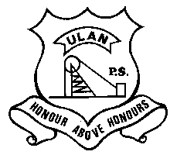 | ULAN PUBLIC SCHOOL  A member of the Cudgegong Learning Community – promoting public education  Main Street, ULAN NSW 2850  Ph: 0263 734625 Fax: 0263 734807 ABN: 7 139 345 454 | CUDGEGONG LEARNING COMMUNITY

NEWSLETTER 10th February 2020
TERM 1 Week 3

SWIMMING CARNIVAL
The Mudgee Small Schools Swimming Carnival scheduled for tomorrow at Mudgee Pool has been postponed until next Tuesday 18th February due to the probability of rain and storms.

SCHOOL BANKING
Any students wishing to do school banking for 2020 our banking day continues to be on Wednesday. If you require further information please call Mrs Lewis in the school office or pop in for a visit

BOOK CLUB
Reminder that Book Club orders are due back by Monday 17th February.

UPCOMING EVENTS

Tuesday 18th Feb – Mudgee Small Schools Swimming Carnival @ Mudgee Pool
Sunday 1st – Monday 2nd March - Year 6 Young Leaders Excursion to Sydney
Tuesday 3rd March – Life Education Van Visit to UPS (with Goolma PS & Cassilis PS)
Thursday 5th March – Friday 6th March – Year 5/6 Eco-Schools Leadership excursion to Red Hill

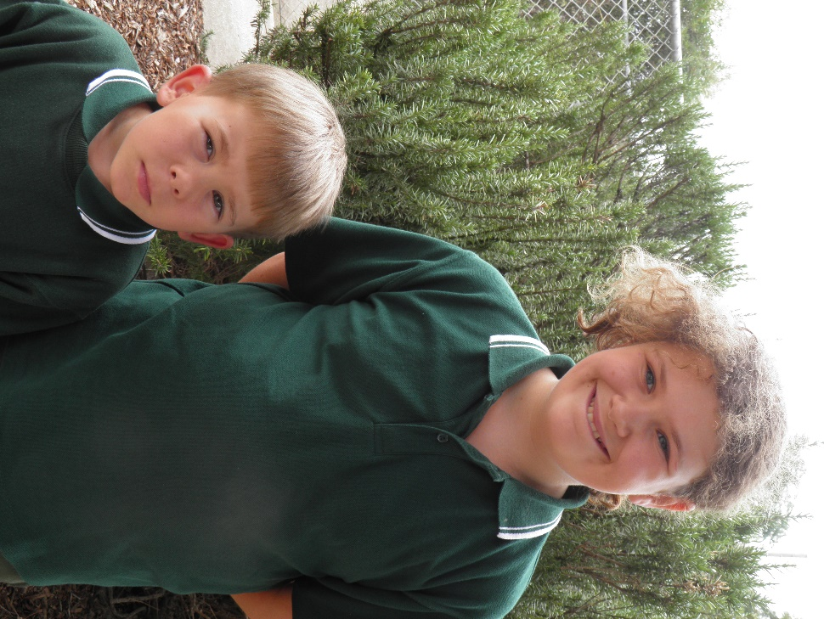

STUDENTS OF THE WEEK
Ulan Junior – Jack Bierton for settling in to class routines well.
Ulan Senior – Ashlee Milton for outstanding application to all her learning tasks.

CONGRATULATIONS JACK AND ASHLEE

