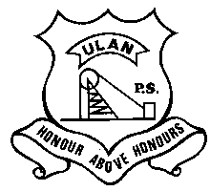 | ULAN PUBLIC SCHOOL  A member of the Cudgegong Learning Community – promoting public education  Main Street, ULAN NSW 2850  Ph: 0263 734625 Fax: 0263 734807 ABN: 7 139 345 454 | CUDGEGONG LEARNING COMMUNITY

NEWSLETTER 3rd February 2020
TERM 1 Week 2
A BIG UPS WELCOME
I’d like to welcome back all our returning students. It was wonderful to see all the familiar smiling faces again after a long summer break.
I’d also like to give a huge WELCOME to our four new students starting at Ulan PS this year.

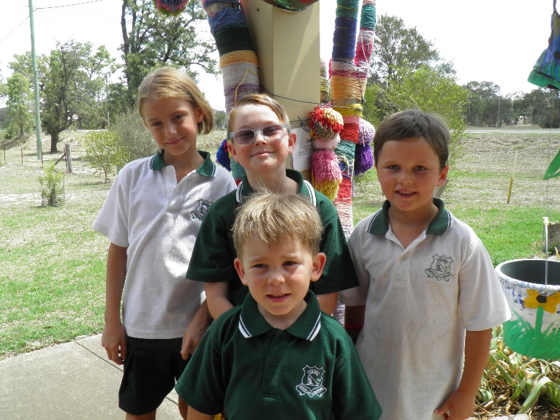
What a good looking group – (B) Lucy, Cory & Heath (F) Jack

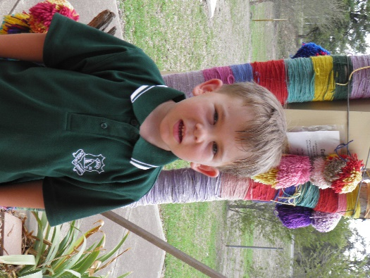

Hi I’m Jack and I’m in Kindy. My favourite colour is purple. I enjoy learning my numbers 1-10 in plasticine and I really enjoy travelling on the school bus every day.
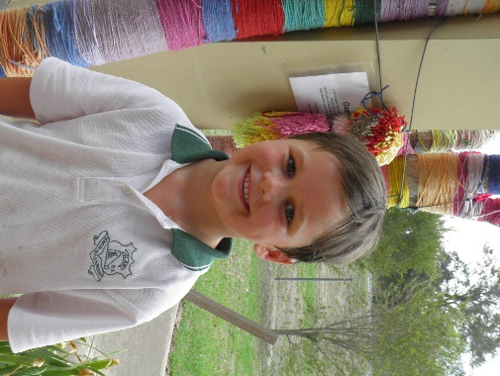
I’m Heath and I’m in year 1. I used to go to Hargraves School before Ulan. My favourite colour is red. Ulan School is a pretty good school as I like playing tennis and seeing Class Dojo. I’m happy I’m here because when the small schools get together, I get to see my old friends from Hargraves.
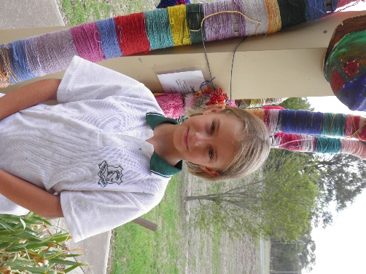
My name is Lucy and I’m in Year 5. I used to go to Gulgong Public School. Ulan School is different in every way to Gulgong School, but in a good way. There is definitely better learning here at Ulan. I do miss my friends from Gulgong, but have made new ones here at Ulan.
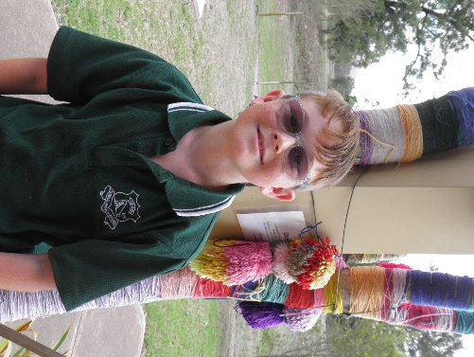
What’s up people? I’m Cory and I’m in year 6. I went to All Hallows School before I came to Ulan. I love everything about Ulan School and have made great friends. I’m looking forward to having a great year.

SWIMMING CARNIVAL
The Small School Swimming Carnival will held on Tuesday 11th February at Mudgee Pool. All students K-6 are able to attend. Those turning 8 years or above this year are able to participate in the competitive races. A permission note is attached.

BOOK CLUB
Attached is the first issue of Book Club for 2020, orders are due back by Monday 17th February.

P & C NEWS
Ulan P&C is always looking for helpers in their fundraising events. Our main fundraisers for the year are the BBQ’s that Ulan Underground Mine offer the school, where they need help with cooking and serving on certain days during the year. All help would be greatly appreciated as the money raised goes back to the school to help pay for activities or resources that assist the students. For first term, iceblocks are sold at lunch time for 50c, which is very popular.
Our first meeting will be announced shortly, so if you have a spare moment and are able to come along, everyone is most welcome. Look forward to seeing you there.

STUDENTS OF THE WEEK
Ulan Junior – Aaron Hodge for coming back to school with a positive and responsible attitude.
Ulan Senior – Paige Lawson for first place on the current Matific Maths leaderboard

UPCOMING EVENTS
Tuesday 11th Feb – Mudgee Small Schools Swimming Carnival @ Mudgee Pool
Sunday 1st – Monday 2nd March - Year 6 Young Leaders Excursion to Sydney
Tuesday 3rd March – Life Education Van Visit to UPS (with Goolma PS & Cassilis PS)
Thursday 5th March – Friday 6th March – Year 5/6 Eco-Schools Leadership excursion to Red Hill

