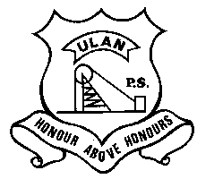 | ULAN PUBLIC SCHOOL  A member of the Cudgegong Learning Community – promoting public education  Main Street, ULAN NSW 2850  Ph: 0263 734625 Fax: 0263 734807 ABN: 7 139 345 454 | CUDGEGONG LEARNING COMMUNITY

NEWSLETTER 15th November 2019
TERM 4 Week 5
YR 3-6 EXCURSION
Senior Class leave for Broken Bay on Tuesday morning, Mr Ferrie will be driving our school bus to and from Brooklyn Ferry terminal. Students need a packed morning tea, lunch and drink bottle for Tuesday, all other meals are catered for. Please be at school by 6.45am. Attached is the itinerary and packing list for your info.

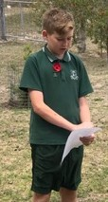

Students participating in Remembrance Day

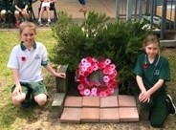
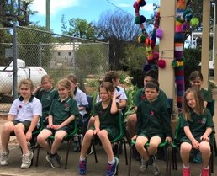

BOOK CLUB
The last Book Club brochure for 2019 is attached, orders are due back Monday 2nd December.
UPCOMING EVENTS
Tuesday 19th to Friday 22nd Nov. -Senior Camp at Broken Bay.
Monday 2nd Dec to Friday 13th Dec. – Learn to Swim at Gulgong Swimming Pool
Tuesday 17th Dec-End of Year Presentation

STUDENTS OF THE WEEK Ulan Junior – Skye Hartley for excellent participation in fitness.
Ulan Senior- Molly Fay for always being meticulous when conducting science experiments.

